Version: Date of print.

Orcad

Capture
Lite edition

( schematic )

This is a compendium, describing the installation of Orcad rel. 9.2
It alsoworks as a “getting started” drawing schematics on PC.

If there are mistakes, or you feel, something is missing, please let me know, giving me a change to correct new versions.

Valle.
About the program!

Orcad Capture Lite Edition is a program, that can be used for drawing a electronic circuit. The circuit can be either a schematic drawing simply for documentation, or a schematic used for simulating with the included program PSPICE.

The program was created after merging two companies in 1998. The company ORCAD originally made the program Orcad schematic drawing program and the company Microsim a program for drawing and simulating. The simulating part was called “PSPICE”.

Now Capture ( = drawing a schematic ) is front end for PSPICE.

The company, of course, wants to sell its products and to spread the knowledge to it. That’s why a “Demo Version” is free.

The version is fully functionally, but decreased in numbers of libraries and decreased in number op schematic components that can be saved.

The version 9.2 was released in late 2000.

Installing the program. !

Run D:\setup.exe

Choose the following for installing. Capture CIS is for online database use, fx with component cost price and outline, and Layout is for Print Circuit Layout.

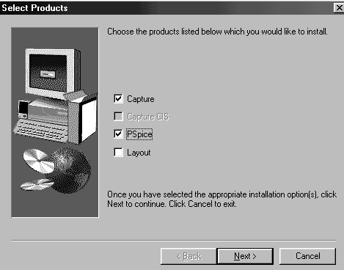

In the Launch-library the following shortcuts ( or some of them ) are created by the installation program:

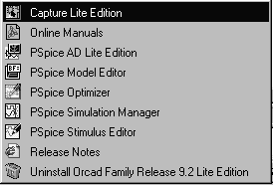

Start drawing Schematics with Capture Lite Edition

Structure

When Capture is started, the project manager shows up. From here it is possible to open a existing project, a library or a design. Further the project manager keeps a session log, that describes the result of the work, that has been done. ( simulating, list of materials etc. )

When a project is created, also a number of files belonging to the project are created.

A project is saved in a “.opj” file. The design itself is included in a “.DSN file”. ?

The project manager can show a project in two ways. . “File view” or “Hierarchy view”.

In “File-view” it is shown, where and how the elements in a design are filed.

In “Hierarchy-view” it shows the way the design-elements are used. Here all components can be found.

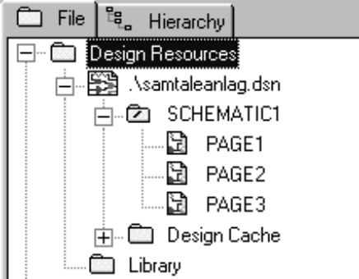
A project can only include one design. A design includes at least one schematic. ( Schematic1, Schematic2 etc. ) And a schematic is a folder, that has at least one page, and it is on these pages the single diagrams or schematics are located.
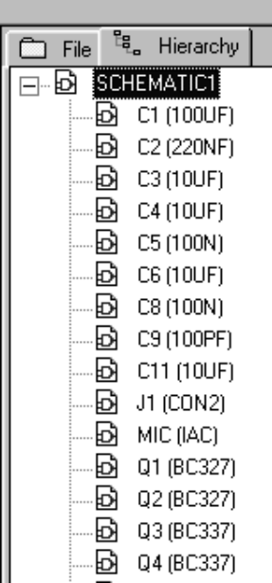
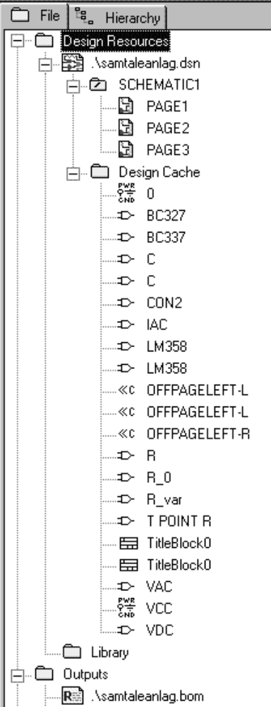
Examples of a project called “Samtaleanlag”. It includes one schematic with 3 pages.

To the right you see an unfolded structure.

The design contains a design cache, a library containing a copy of all components and symbols used on the schematic pages.

On a schematic page all the elements, describing the circuit are placed. Fx. Parts, Symbols, Wires, Labels, Text, Off-page connectors, Netnames, etc.

Start a new circuit drawing / diagram :

The program is started with ”Capture Lite Edition”.

Now a new project can be created ( “File / New / Project” or Click “Create Document” ) - or a saved project can be opened!
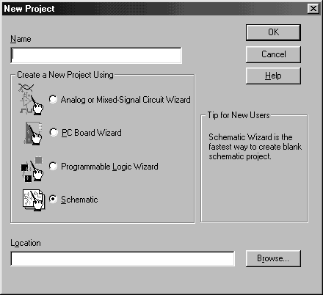

Give the project a name.

Decide in “Location” where to save the project files, fx. \Orcad\..\Projects.

Now you choose what is the idea with the schematic.

If it’s just for drawing, and copy and paste to Word you choose ”Schematic”. If it’s for simulating later on, choose ”Analog or Mixed-Signal Circuit Wizard”.

Click OK

( Eventually a number of libraries that can be included in the project are shown. Just click OK. )

If you are asked weather to start a hierarchic or a blanc project, choose the blanc !!

Now you get a page with a “breadboard” where component symbols or parts can be placed.

Example: ( Next page )

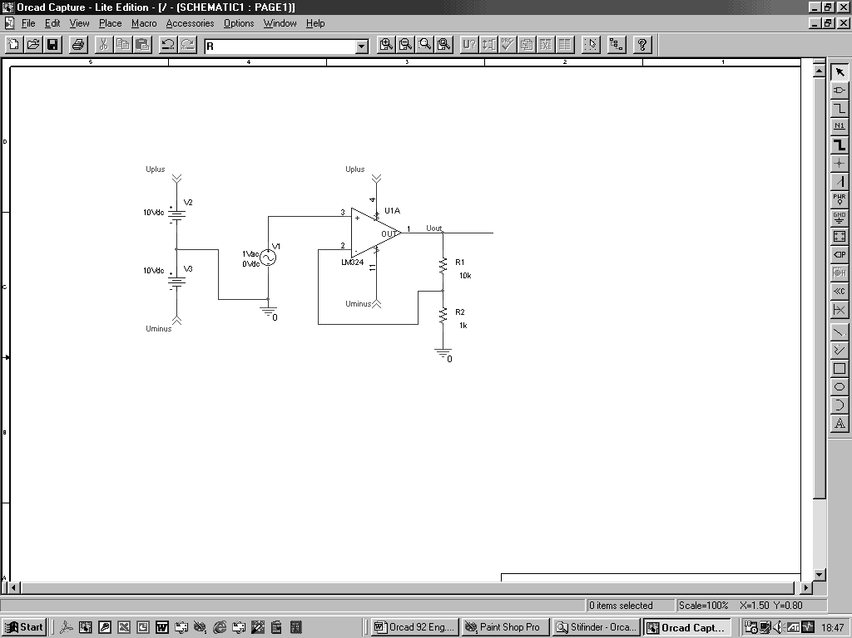

To place component symbols / Place part

Default ”GRID SNAP” is ON !!!! ( Or choose Options / Preferences / Grid Display / Pointer Snap to Grid.

For only drawing schematics for dokumentation, all component symbols in all libraries can be used. If the schematic is drawn for simulating, only the symbols in the library \PSPICE may be used.

Click on the gate symbol on the right side, and you get a dialog box. “ Place part”

In the bottom left corner in the Place part dialog box you’ll see the libraries added to the project. More can be added, ( “Add Library…” or libraries can be removed.

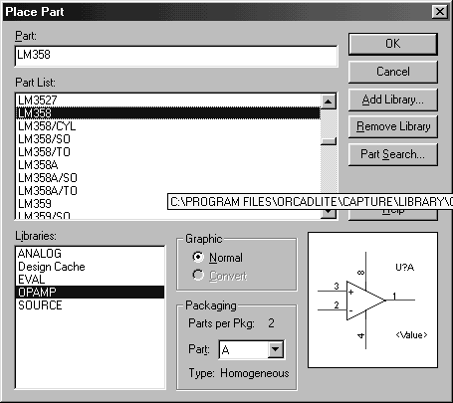

If the added libraries are highlighted, you can search all of them for a specific component. In “Part” you specify which you want to see.

*358* + “RETURN” will show all components, containing “LM358” in their name. *58 shows all components ending on “58”. LM?58 gives LM158, LM258 and LM358. LM*58 all starting with LM and ending on 58.

Highlight one of the components, and it’s schematic symbol will be shown.

Arrows up / down shows previous / next part.

OK will take the selected symbol to the “breadboard”.

Searching for Parts:

If the wanted component can’t be found in the libraries added to the project, you can add more.

If you don’t know in which library, a component can be found, use the ”Part Search” - function.

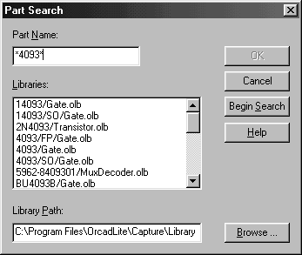

Type in fx. *4093*. + “Begin Search” will search in all libraries ( .olb ) and show in which, a component containing the string “4093” can be found.

Highlight the component, and “OK” will add the library to the project.

Place the desired component on the screen. Eventually place more components. <ESC> - or right click and “END MODE” for stopping the place activity.

“Design Cache”

In the top of the screen a “Design Cache” can be found. From here it’s easy to get more of the most resent placed components

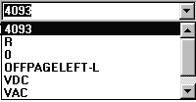

Copy of a component

By highlighting a component it can be copied. Just press <Ctrl> while moving it.

Select Part in ”PACKAGING”.
If there are more components in a package, fx there are 4 NAND-gates in a package, it is possible to choose number 2, 3 or 4 in the package before placing it on the board. Select Part in ”PACKAGING”.

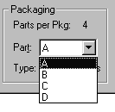

Edit Parts:

It is easy to edit the drawing. With the mouse objects are selected, more objects by help of <ctrl>, or all within an area chosen with left mouse button. Right mouse button gives a menu with the most used functions in the situation.

Highlight a symbol. Press <ctrl> and move a copy of the symbol to another place.

A Part can before ore after placing be rotated, mirrored etc.

Highlight the component.

Right mouse + Rotate, Right mouse + Mirror etc.

Highlight either the part, the value of fx. a resistor etc. and it can any time be moved.

Part Properties.

The Property of a part can be changed. A resistor number fx. R3 can be changed to fx. R1, and a component value fx 10 nF can be changed. Double click on “R3” or on the value.

Place Wire.


Connections between components are created with “Place Wire”

When a wire connects to a component or a ”PIN” a red spot will show up to indicate correct connection – and the tiny square box disappears.

Net Name

When a wire ( or a bus ) is placed, it gets a system generated name. It is called a “NET-Name”. Fx. N00761. This name can with advantage be changed to another more interesting name. Also called a “Alias”, fx. Uin, Uout, N1, U1 etc.


Click N1 on the right side:

Type in the name, press OK and place the Alias on the wire.

The Net name eventually can come from a Off Page Connector. ( See later ). The whole wire connected to it has the same name.

The NET Name of a wire can be examined by a double click on it. In the spread sheet the name is displayed.

Junction


Wires can cross each other without any junctions. If a junction is desired, place a ”junction” with “ADD Junction”!!

A junction can be removed by placing another junction on top of the first!

Move component or wire

A component or a wire can be moved without disturbing the connection. Pressing <ALT> under moving will move only the component or a part of a wire.

Wire direction

If wires has to run in other directions than 90 degrees press <Shift>

Place BUS

A bus is placed as a wire.

A bus must have a name to decide how wide it is. A bus-alias could be A[0:3], Which means a 4 bit wide bus, with the wire names A0, A1, A2 and A3. Also A[0..3] and A[0-3] will do.

A wire can’t be connected directly to a bus. A bus entry is placed on the bus, a wire is connected to it, and the wire is called the same as one of the bus wires.

More bus entries can be made by high lighting one entry, and move a copy of the first entry while pressing <CTRL>.

Special components

Symbols for “Power Supply” and “Ground” can be found on the right side.

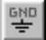

Power objects are used to show where in a circuit the power supply is connected. If different symbols have the same name, they are connected. ( The library CAPSYM.OLB is used )
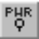

To the right there are shown a power supply. In a schematic all symbols with the same name are “connected
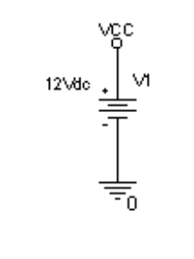

A double click on the symbol text lets you change it.

Ground

It is important if the circuit is for simulating with PSPICE, that there are placed a ground symbol. Use the one called “0”.

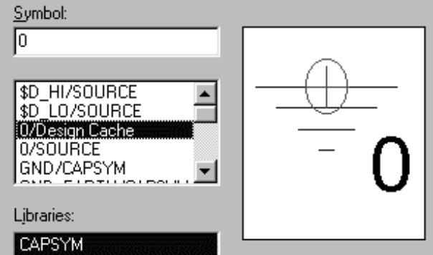

Off Page Connectors

If a signal continues another place on the page, and a wire will be too disturbing, a “off page connector” can be used. Two with the same name are “the same Wire”. This even can be used for connecting signals on different pages.


Press “Off page Connector”, choose one, and give it a name.

Bill of Materials:

In the project manager you can print a bill of Materials. High light the wanted page, and click “Tools/Bill of Materials”.

Symbols as fx. Power, Off-page connectors, Tittle block etc. will not be put on the component list.

Printing:

To print the schematic chose File / Print. You can fx.

“Scale to Paper size”.

Force to Black & White.

Scale from 0.100 to 10.000

In OPTION / Preference you can choose colour on the print. Part values, ( component value ) or part numbers ( Part references ) can be omitted from the print.

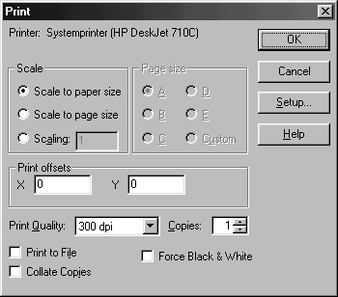

Copy of a schematic to Word:

Copy of a schematic or a part of the schematic can be done via the clipboard. Or the capture function in fx. Paint Shop Pro can be used. With Capture a whole schematic, or a part of it can be transferred to word.

First in “View”, turn off the Grid.

Paint Shop Pro can be used to manipulate a picture. Useful is Colors / Gray Scale and Colors / Decrease Color Depth / 2 Colors. The word file then won’t grow to big.

In Paint Shop Pro also a selection of a picture can be made, and then will Image / Crop to Selection remove what is outside the selected area.

If you want to remove a part of the picture, put a selection around it. Choose the airbrush, and spray it with a white colour.

Copy and Past brings the picture into Word.

Libraries:

Below the libraries are shown. All components in all libraries can be used for schematic drawing, but only components in the directory Pspice may be used when simulating a circuit.

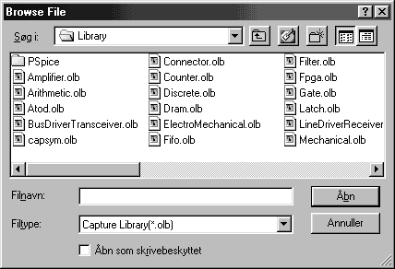

And the rest when scrolled right.

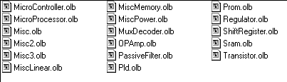

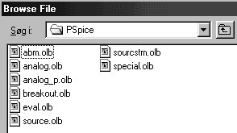

In the subdir Pspice the libraries to the right can be found:

And below there are a list that might help to find special symbols for drawing schematics.

Remember, that if the schematic is intended for simulating, only use the symbols in the sub directory PSPICE.

First the sub directories in the directory PSPICE:

 |  | Some of the contents
Pspice  library \ | Abm \
Pspice  library \ | analog \ | C, C_elect (olyt), L, OPAMP, R, R_var
Pspice  library \ | analog-P \
Pspice  library \ | Breakout \ | Pot
Pspice  library \ | eval \ | 555, 74xx, A4N25, d, D1N4148, LM324, SW_tClose, SW_tOpen, Q2N3904 (NPN-transistor), Q2N3906 (PNP-transistor)
Pspice  library \ | Source \ | DIGClock, IAC, IDC, IPULSE, IPWL, ISIN, VAC, VDC, VPULSE, VSIN, VSRC
Pspice  library \ | Sourcestm \ | Digital stimuli, ( input signals )
Pspice  library \ | Special \ | IC1 and IC2 ( initial Condition for capacitors ), PARAM

Components from the following libraries only for schematic drawings !
Can’t be simulated !

Library: | Some of the contents
Amplifier
Arithmetic | 4585,
Atod
Bus driver
Transciever
Capsym
Connector | Test point, Jumper, Jumper2, Header1, Header2, Connector  coax-m, Con1, Con2, T point
counter | Cmos counter, 140xx, 45xx, 74HCTxx, 74LSxx, CD40xxx, CD45XX, 40110, HEF4xxx, SN74ALS, A, F, HC, LS
Discrete ??? | 1RSW3, 1RSW6, ( 3 – 6 omskifter ), Relays, 2Nxxx, 4N25 ( opto coupler ), Crystal, 5101H (led), Battery, Bridge ( diode bridge), C, Polarised capacitor, CAP ( capacitor ), cny17-1, ( opto coupler ), Crystal,  DF2E-DPDT ( double. shift relay ), DIODE, DIODEZENER, DK1A-SPST (Relay, 1x on/off), DK1A1B-DPST( relay, 2 contact), FUSE, G4B-SPDT (relay, 1 shift), INDUCTOR, JFETN, JFETP, LAMP, LED, LXR-4206 ( photodiode),  MAC6400 (Triac), MOC3040, MOC3041, MOSFETP, MOSFETN, OP550D ( phototr. ), POT, PNPDIAC, PTC, R2 (European resistor), RELAYDPDTHE (shift contact without coil ), RELAYDPSTHE (do), RESISTORSIP6 ( 4-8 Sil ), RESISTORVAR, RESISTORVAR2 ( with arrow over ),  RFDPDT ( Manuel contact), RFSPDT ( Manual contact), SCR, SG531 ( out-terminal), SIGNALAC, SmallCAP, SourceCURRENT, SOURCEVOLTAGE, SPEAKER, SW3PDT, (Switch manuel), SW4PDT (do.), SWDIP-2 ( 2-8 dip switch), SWDPDT/SM (2pol switch), SWDPST (2pol contact), SWKEY-Y1011 (shift contact), SWKEY-YM061 (on/off), SWMAG-SPDT (shift contact),SWPUSHBUTTON, ( more examples ), SWROTARY1P-10W, SWROTARY2P-5W, SWSPDT (shift contact), SWSPST (on/off-contact),  TPOINTR (Terminal round ), TPOINTS (square terminal),  TERMALFUCE, THERMISTOR,  TO220 (house), TO39, TO92 (house), TRANSFORMER, TRIAC, TRANSFFMR…( more examples ), ZTA ( crystal).
Dram
ElectroMechanical | Motor AC, Motor Stepper,
Fifo
Filter
Fpga
Gate | 140xx, 40xx, 45xx, 74xxyy, AND2 (2-16), CD40xx, CD45xx, HFE40xx, NAND2 (2-16), NOR2 (2-16), NOT, OCPAD (Terminal), OR2 (2-16), SN74xx, XNOR2 (2-16), XOR2 (2-16).
latch
LineDriver/Receiver
Mechanical | Dip sockets,
Microcontroler
Microprocessor
Misc | METER ( different measurement instruments !)
Misc2
Misc3
MiscLinear | LM555,
MiscMemory
MiscPower
MUXDecoder | 4051,
OPamp | 1458, CA741, LM324, LM358, LM741, TL072, TL074
PassiveFilter
PLD
Prom
Regulator | 78xx
ShiftRegister | 4015,
SRAM
Transistor | BC547, BC557, BC337, BC327 mm.

An example of a schematic:

